TCGA-PRAD analysis for 3 interested genes: FCGR3A, FOLH1 and PTGS2.

The gene expression data of TCGA-PRAD (Prostate Adenocarcinoma) was downloaded from GDC data portal using the TCGAbiolinks Bioconductor package. The data was then analyzed in R studio using R (version 4.60), to investigate the specific relevance of the 3 interested genes in prostate cancer: FCGR3A, FOLH1 and PTGS2.
- mRNA expression analysis between normal condition and primary tumors
Since the TCGA, unlike the MSKCC2010 dataset that Martina used, focused specifically on normal and primary tumor sample groups and had just 1 sample that was at the metastatic tumor condition, the comparison for these three genes was done between normal and primary tumor conditions.
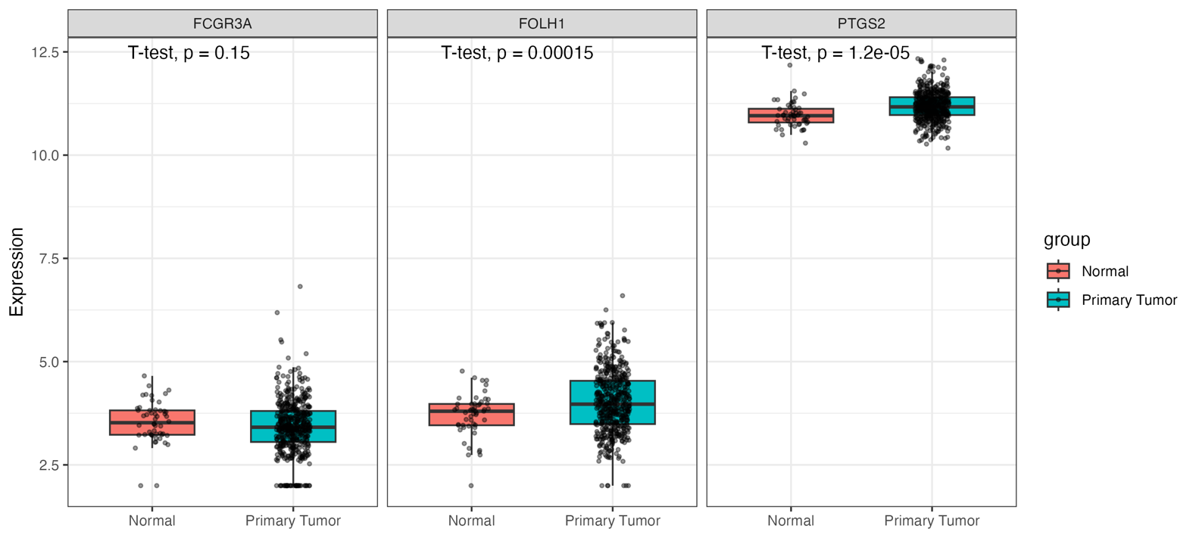

Gene | p.value | t.statistic | Significance
FCGR3A | 0.14798176 | 1.46291175 | ns
FOLH1 | 0.00015256 | -3.9891322 | ***
PTGS2 | 1.22776996652596e-05 | -4.7305721 | ***

The expressions of both FOLH1 (p value: 0.0002, and t statistic: -3.989) and PTGS2 (p value: 1.228e-05, t statistic: -4.7305721) differed significantly between the normal and primary tumor conditions. The boxplots show that both these genes’ expressions were higher in the primary tumor condition compared to the normal condition, whereas FCGR3A did not show a statistically significant difference (p value: 0.1480). In Martina’s MSKCC cohort, where she compared between primary and metastatic tumor conditions, only PTGS2 showed a significant difference in expression.
What was interesting, and that I can’t really explain when comparing Martina’s and my results, is that, at the primary tumor condition, FOLH1 is expressed higher than PTGS2 in my results, but the vice versa in Martina’s results.

- Gleason Scores for primary tumors
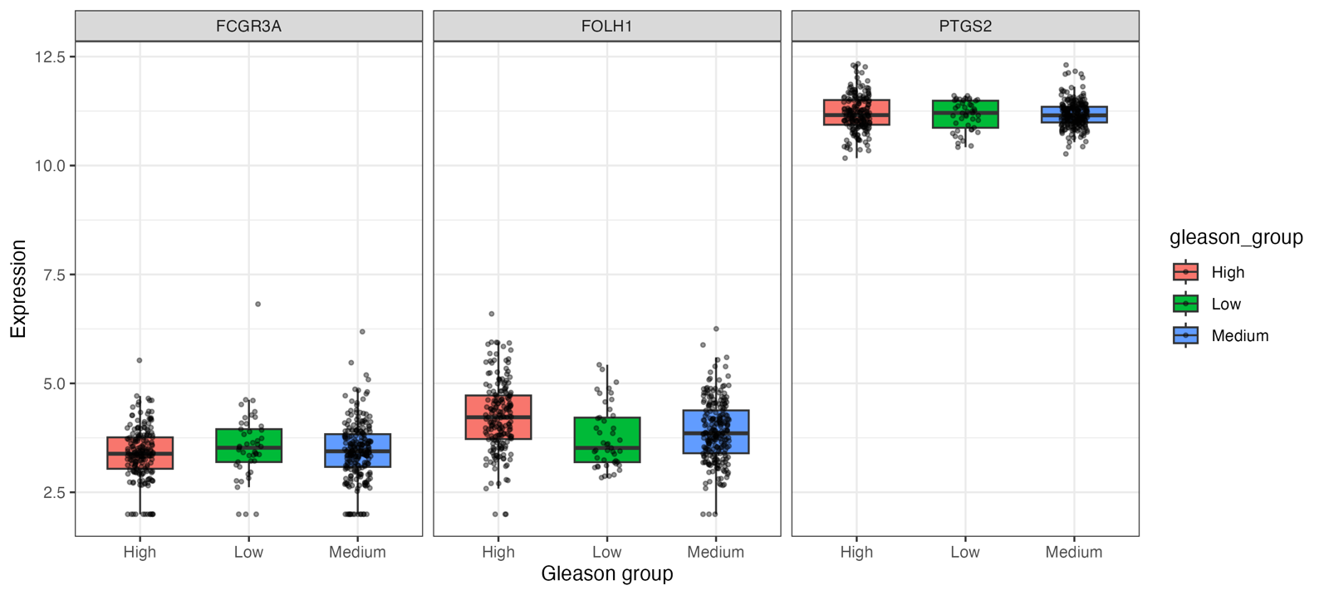
Gene | Source | Sum_of_Squares | df | Mean_Square | F | Sig | Stars
FCGR3A | Between Groups | 1.0338523 | 2 | 0.51692615 | 1.2071984 | 0.29996133 | no
FCGR3A | Within Groups | 200.827275 | 469 | 0.42820314 | NA | NA
FCGR3A | Total | 201.861127 | 471 | NA | NA | NA
FOLH1 | Between Groups | 15.0109302 | 2 | 7.5054651 | 13.6778599 | 1.68486793816753e-06 | ***
FOLH1 | Within Groups | 257.354817 | 469 | 0.54873095 | NA | NA
FOLH1 | Total | 272.365747 | 471 | NA | NA | NA
PTGS2 | Between Groups | 0.11065771 | 2 | 0.05532885 | 0.44050923 | 0.6439746 | no
PTGS2 | Within Groups | 58.9073525 | 469 | 0.12560203 | NA | NA
PTGS2 | Total | 59.0180102 | 471 | NA | NA | NA

- Survival study via Kaplan-Meier curve
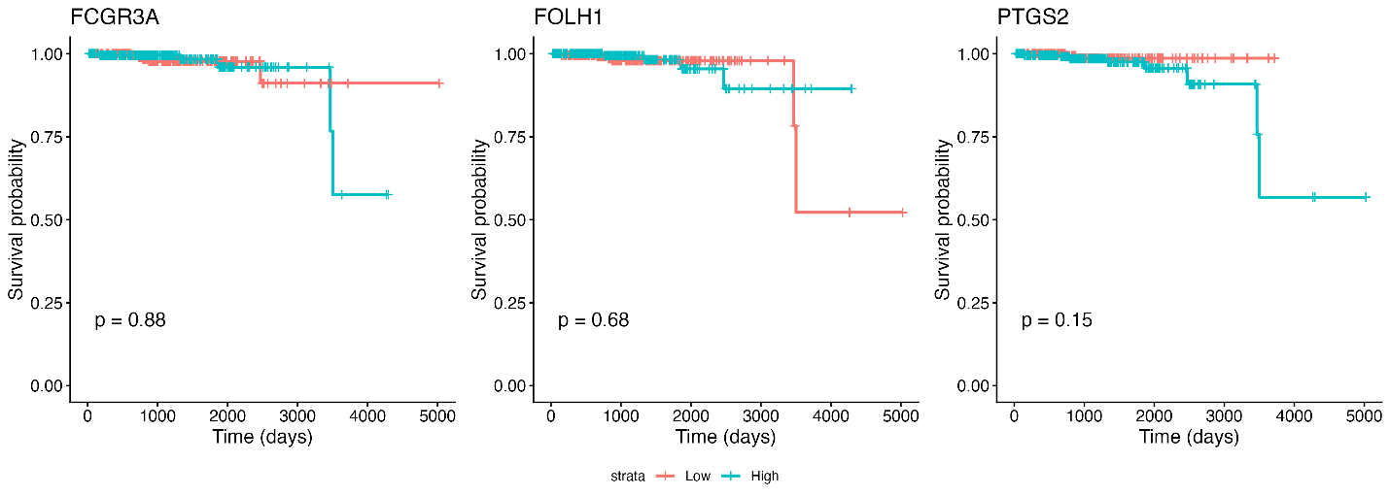
Gene | Test | Chi_Square | df | Sig
FCGR3A | Log Rank (Mantel-Cox) | 0.023 | 1 | 0.88
FOLH1 | Log Rank (Mantel-Cox) | 0.172 | 1 | 0.678
PTGS2 | Log Rank (Mantel-Cox) | 2.046 | 1 | 0.153

Interestingly, neither of the three genes showed a statistically significant association with patient survival, which is different from the observation made by Martina, which was that the patients with high PTGS2 had a different survival probability compared to those with low expression.

- Heatmaps
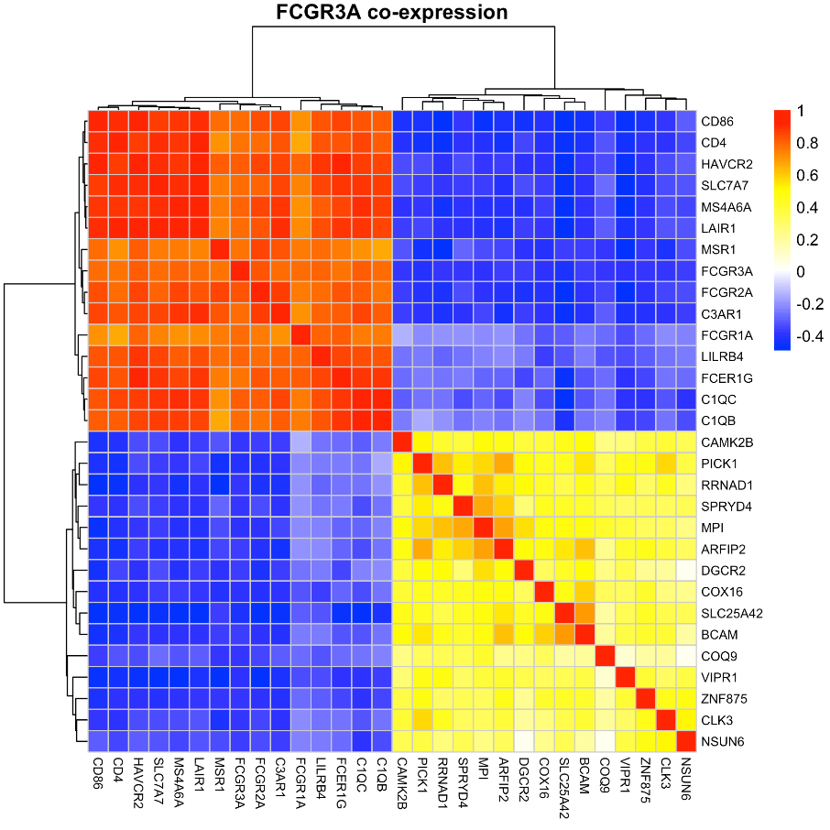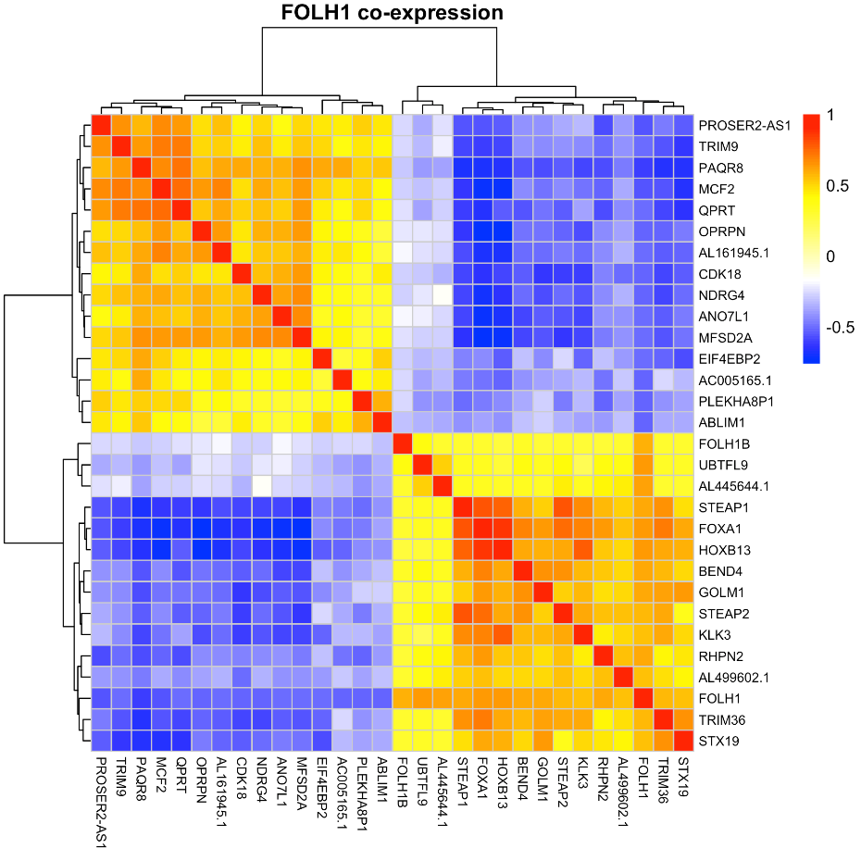
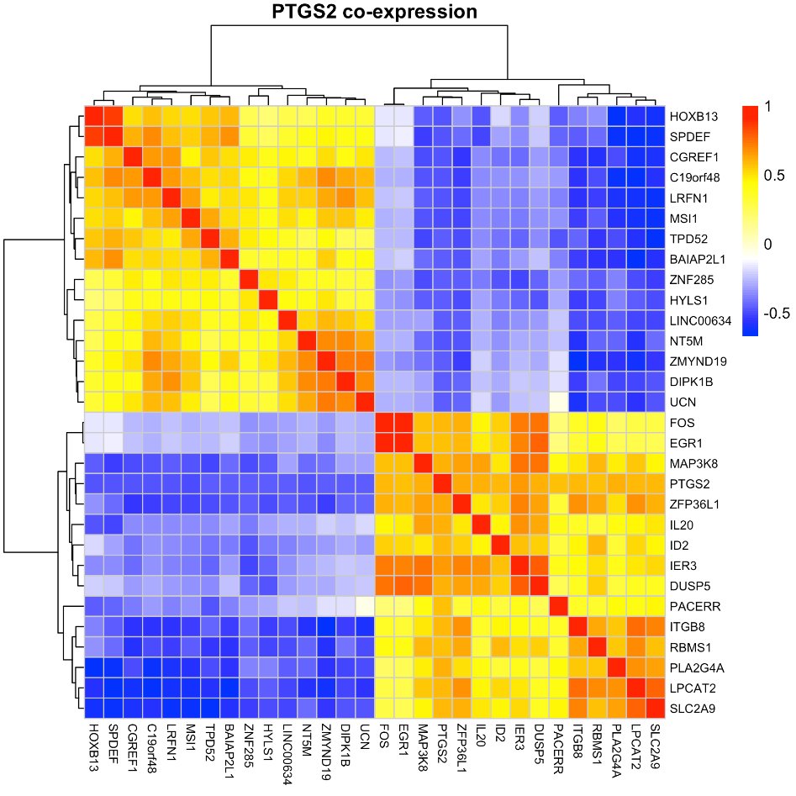

MSKCC2010 analysis for 3 interested genes: FCGR3A, FOLH1 and PTGS2.
Comparison with Martina’s report

- mRNA expression analysis between normal condition and primary tumors
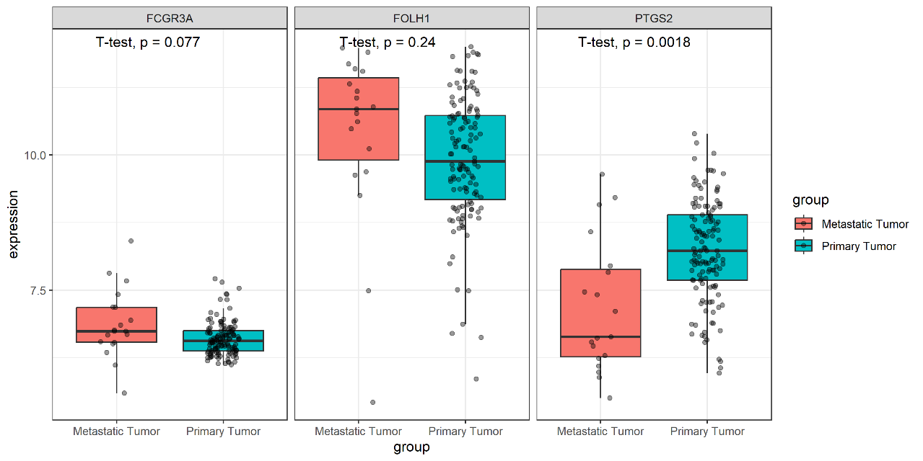
- Gleason Scores for primary tumors
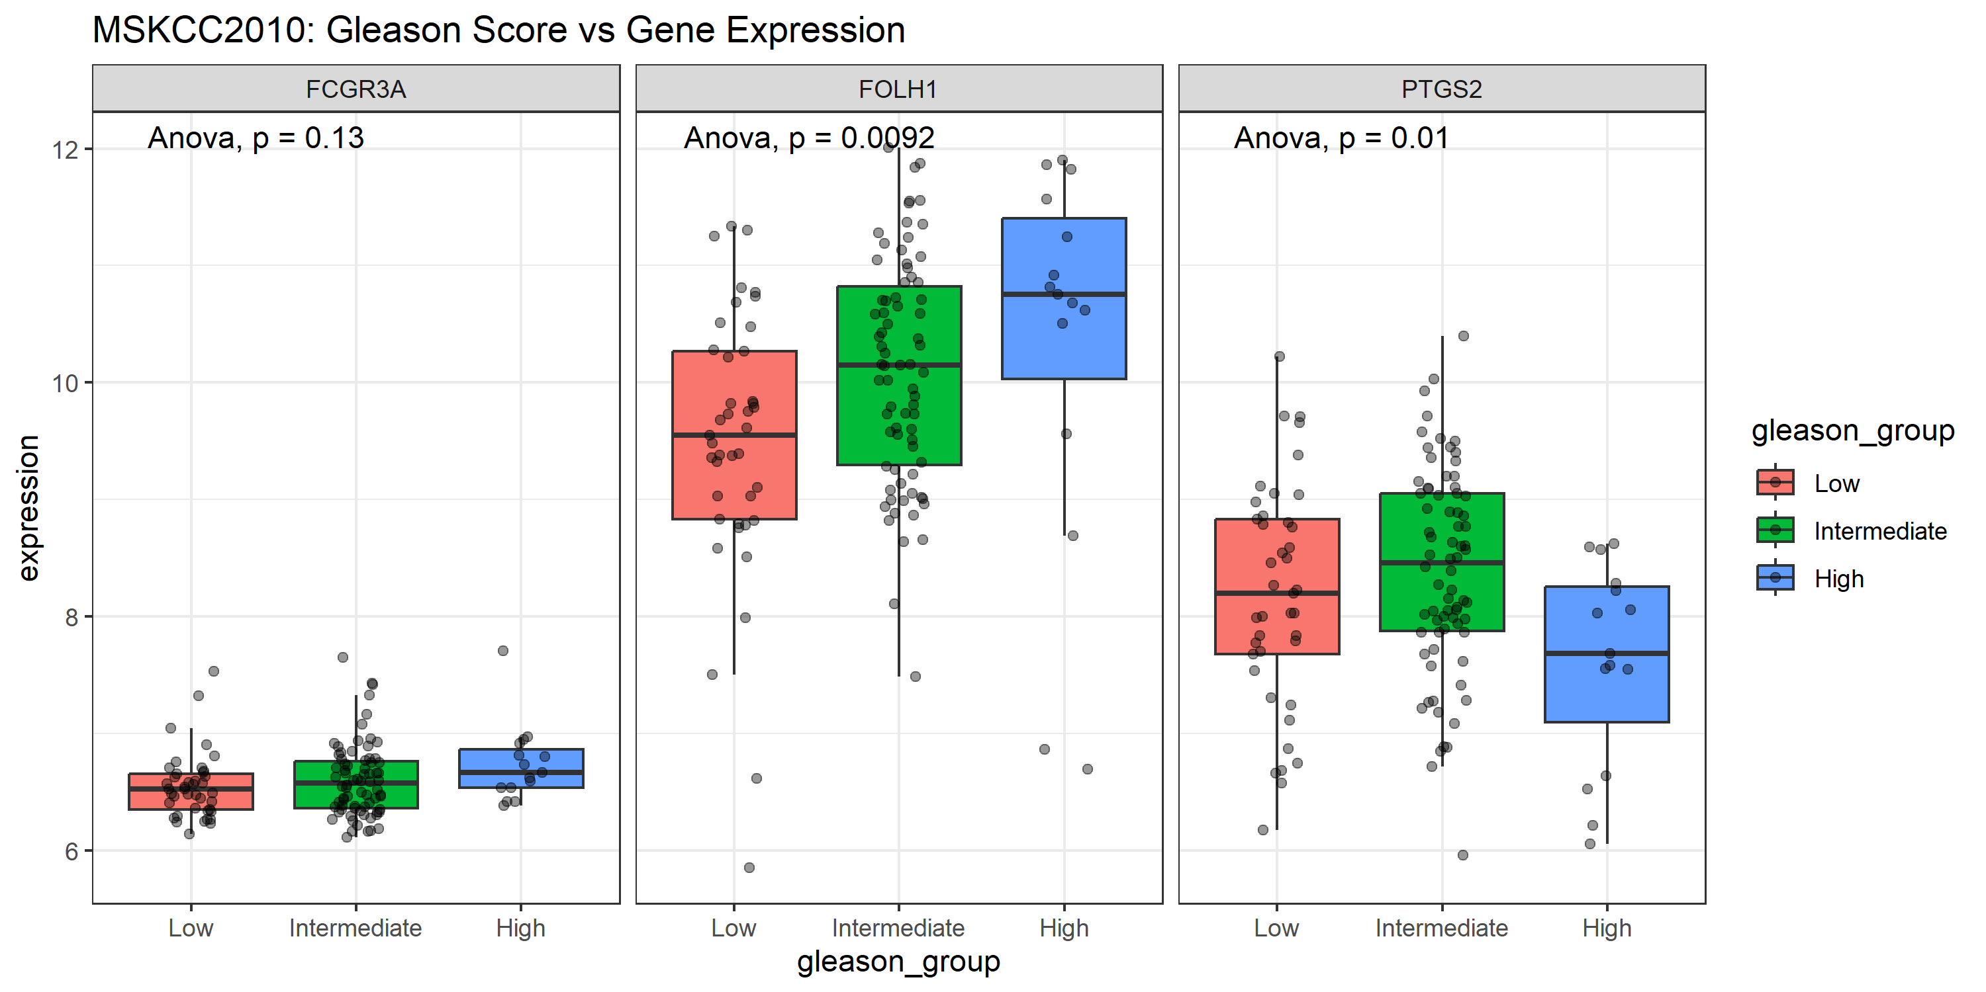

- Survival study via Kaplan-Meier curve
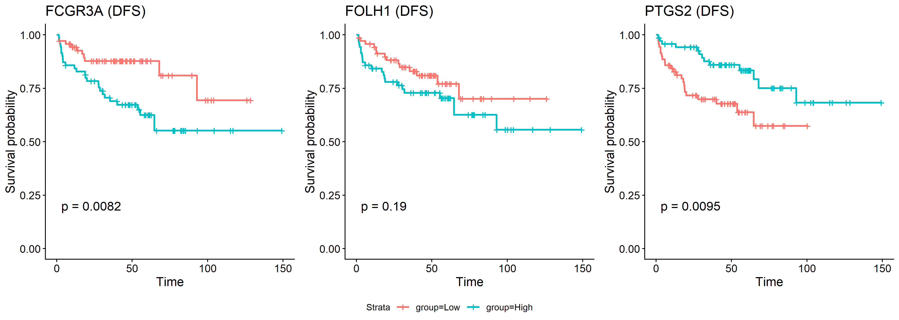

- Heatmaps
- 